

**Lab Goal:** The goal of the lab is to analyze the issue at hand and allow each individual Jeroo to reach their destination and obtain their flowers using a single method including at least one loop.

**Lab Description:** This lab requires you to use a wide variety of if commands. Use one method to transfer the Jeroo from inside of the map to the exterior and to pick the flower. Use loops to make sure that the Jeroo does not become trapped in a net or fall in the water.

.



**Starting Screen:**

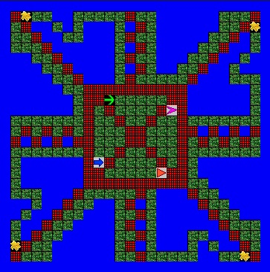

**Ending Screen:**

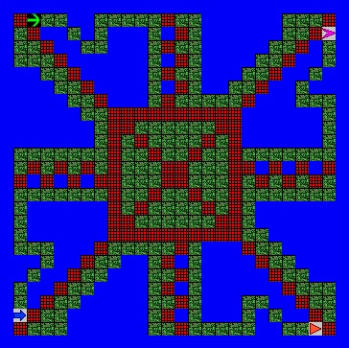

**BONUS: Write the loop and ifs as part of a method to solve the maze. +10**